Report to: City Deal Executive and Stewardship Board
Private and Confidential: No
Date: Tuesday, 25 April 2024
Scheme | Project summary | Stage | Total Project Value | Update
Animate | Bus stop improvements at Station Road and near the railway station. | On site | £45.8m  (CD commitment £3.25m) | The construction activity on site continues at a pace. The steel frame is complete along with the roofing. The external façade is progressing on all sides, with the installation of the SFS walls, insulated cladding panels, decorative cladding and brickwork. The curtain walling and glazing is being installed, allowing the internal partitioning to commence. The works remain on programme for completion on the 28 October 2024, however the contractor has lost time on the external façade, due to the wet weather over the last few months. Progress is being closely monitored to ensure any mitigation plans can be implemented to maintain the completion date.  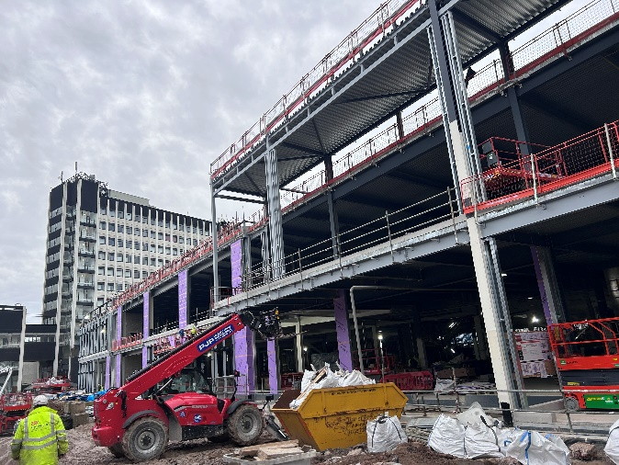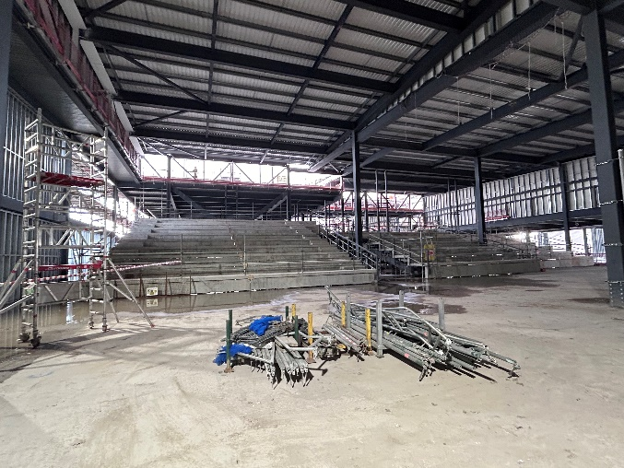  The planned works over the next few months will see the external walls completing, and the internal fit out progressing.  In addition, the approved off-site highway works will shortly commence, comprising of alterations and improvements to the A59 eastern slip road, Tenterfield Street and the public realm improvements on Old Vicarage in-between the site and the Bus Station.
Harris Museum | Enhanced cultural offer for city and Central Lancashire as part of Harris Museum/Library improvements. | On site | £16m  (CD commitment £1m) | Work is progressing well on the project. The external façade repairs are complete including windows. the central roof lantern glass has been replaced, structured checked and pendulum bracket have been installed.  The planned works over the next few months include:  Containment and electrical installation  New visitor facilities and changing places rooms being created and set for installation.  New stair installation taking place.  Lighting fittings arrived and starting to be installed.  Basement Tanking all complete and room setting out taking place.
A582 / MRN Focused Scheme | Upgrade to the key junctions along the A582, improvements to sustainable travel and delivery of Lancashire Central off site highway works. | Outline Business Case | £70.7m | LCC Cabinet approved the submission of the Outline Business Case which is anticipated to be submitted to DfT in April 2024 and for the Lancashire Central Off-Site highway works to be delivered under the MRN due to similar delivery timescales and the common road network.  Following approval of the business case, public consultation events will be held to share the designs for comments.
North West Preston Linear Park | Delivery of green space at the North West Preston Strategic Area | Design | CD commitment £10m | The City Deal Preston Western Distributor has unlocked over 5,000 homes in North West Preston. To compliment the development a park is proposed in the area and will be allocated in the next local plan.  PCC are in the early stages of the project. The City Council anticipate that the park will be designed, delivered and maintained by a procured organisation of its behalf, in consultation with the parish council and the local community.  The estimated start date for the linear park is likely to be in the next 3-5 years and will include an alternative off-road route for the Guild Wheel. It will also provide an opportunity to enhance biodiversity as required under new government legislation.

